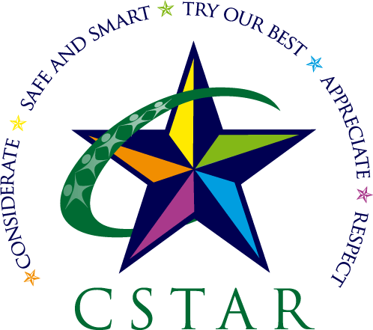
Welcome to Corinda State School Learning at Home

At Corinda State School our main priorities remain unchanged as we transition from learning at school to Learning At Home.
Our aim is to support your family to feel connected and informed as we adapt to this unprecedented event. We want to ensure that our C Star Values hold true.
Consideration of our community needs – families, teachers, support and administration staff.
Safe and Smart – ensuring the safety and wellbeing of us all, making learning choices that are inclusive, realistic and in keeping with the Australian Curriculum.
Try your best – we are all working together to deliver learning at home and we understand that family needs, priorities and circumstances will vary. We trust that you are doing the very best for your family.
Appreciation – the uniqueness of this situation will live with us for a lifetime, find joy in the little things that will occur each day while learning at home.
Respect – be kind as we communicate and learn together. Be respectful in this new environment and be aware of what is sustainable for you, your children and all school staff.

CSS Virtual Classrooms have been designed to:
- provide an option that is clear and simple for families
- be supportive of families who will be learning across multiple year levels
- allow for learning that is home-friendly
- support sibling interaction
- grow in capability as our situation changes and all users have made the transition to online learning

CSS Virtual Classrooms have been created in the following learning bands:
- Prep-Year 1
- Year 2- Year 3
- Year 4 BYO iPad
- Year 5-Year 6

We wish you well and thank you for supporting your child’s learning at home.

Corinda State School Staff

